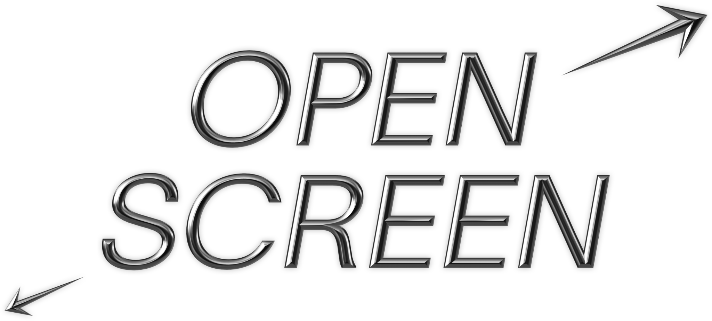

Call out for artists working in the digital realm who self-identify as disabled

Developed in partnership with Shape Arts in 2021, Open Screen is seeking existing works that respond to the theme of SCI-FI, as part of arebyte on Screen, arebyte’s expanded and innovative online platform for digital animations, videos, web-based interactive experiences and curatorial interventions.

arebyte is inviting digital artists self-identifying as disabled to apply who work with technology to their advantage, overcoming barriers, criticising matters of inclusivity within technology, and everything in between.

Open Screen is actively aiming to address an area of underrepresentation in the art industry with proposals exploring the role of digital technologies and the new opportunities it creates or hinders; from experiments in augmented, virtual and mixed reality, to fake news, online bots, social media, darknet and deep fakes.

A panel of judges will select two works that will each receive a £300 artist fee, and curatorial support from arebyte.

What are we looking for?
- Existing work within the realm of digital art, emerging technologies, and new media to be experienced online and that create interesting and ambitious interventions on aos.com.
- Existing works responding to arebyte’s 2022 theme SCI-FI.
- Works can reference disability, but this is not mandatory.

Who can apply?
- Aged 18+ and above
- No restriction regarding location
- Practitioner working in the digital realm who identifies as ‘disabled’ under the Social Model of Disability, regardless of impairment.

The Social Model holds that a person isn’t ‘disabled’ by their impairment or health condition but by the physical and attitudinal barriers they face in society, for example lack of access adjustments, prejudice, and systemic exclusion. There are no requirements to ‘prove’ your
disability or legitimise your experience facing these barriers

Timeline
- 7 March - Deadline for submissions
- 14 March - Selection by the panel of judges
- 15 March - First meeting with arebyte curator (online)
- 31 March - Deadline to finalise presentation of work
- 12 April - Work goes live on aos.com

How to apply?

Please apply via our online form or send an image of your work and a description to opencall@arebyte.com with the subject “Open Screen 2022”

Applications via alternative formats are welcomed. Please make us aware of any access costs for the application process or for making the work (see below).

Access
Some applicants will have access to work funding for access support but if not please let us know of any access needs you may have to apply or any possible access costs in the making of the work by emailing opencall@arebyte.com or give us a call on +44 (0)2045032205 and leave a message. We will get back to you as soon as possible.
We will provide what support we can, whether for example you would like to access the open call in an alternative format (for example: via phone call / online chat / printed format), or you require someone to write and/or submit the application on your behalf.

Though this call out has been carefully constructed, we acknowledge it may not be perfect and welcome conversations about how we could improve as well as feedback on the application process.

FAQ’s for Open Screen 2022

Shortcuts to questions:
How do I apply?
What do you need from me when I apply?
Is there an artist fee?
What art forms are eligible?
Can I apply with an existing work I’ve made?
How competitive are these opportunities?
Do you have access costs available to artists?
I don’t have any documentation of my work – can I still apply?
What is arebyte on Screen?
How will arebyte select the artists?
What is arebyte’s theme of SCI-FI?
Do I need to provide proof of my disability?
Can international artists apply?
I have an access rider, can I include this in my application?
When is the deadline for applications?
Will I have access to arebyte Gallery?
I’m currently studying, can I still apply?
If I am selected, will my work remain on the AOS website after my residency?
Can a support worker complete my application?
Can I apply with a project that I have already started?
Will I receive feedback on my application?
What access costs can you fund?
What is arebyte Gallery?
How will the existing work be credited?

How do I apply?

Please use this online form to complete your application.

If you require support to access, complete or submit the application or find out more information, please contact us. You can email opencall@arebyte.com or give us a call on +44 (0)2045032205 and leave a message. We will get back to you as soon as possible.

What do you need from me when I apply?
You will need to submit the following:
- Information about the existing work you’d like to submit, explaining the concept and outcomes for the online presentation (up to 500 words)
- An optional supporting link or document (this could be an artist CV, website or social media link, and it could be a PDF, word document, website link, imagery/video link etc)
- An access rider you would like to share with us if you use one.

Is there an artist fee?
A panel of judges will select two projects that will each receive a £300 artist fee, and curatorial support from arebyte.

What art forms are eligible?

Any artwork under the umbrella of “digital art”, made for an online experience. This can include (but not limited to) works in code, web design, moving image, audio, Virtual Reality, face-filters, Augmented Reality, etc.

Can I apply with an existing work I’ve made?

Yes. We are only accepting applications for existing artworks or projects.

How competitive are these opportunities?

As this is the first open call we have made specifically for artists who self-identify as disabled under the Social Model of Disability, we cannot say how competitive the open call will be. Other open calls we have put out often receive 50-100 applications.

Do you have access costs available to artists?

We have a small budget which is dedicated to ensuring you as artists can access our programme. These access costs are for those who may need it or haven’t had access to such funds before.
There are also funds such as Access to Work which helps support disabled artists. Please let us know if you would like to access these funds for both the application and overall project.

I don’t have any documentation of my work – can I still apply?

Yes. Supporting material that includes links to your work, website, CV or other document is not mandatory for the application.

What is arebyte on Screen?
arebyte on Screen invites artists and curators to experiment with new forms of creating, curating and showing work online, from designed websites to plug-ins video work, 360 degree presentations, plug-ins, apps and web-based interventions.
arebyte on Screen is a platform dedicated to artist videos and curatorial interventions utilising digital formats. AOS invites web-based artists, digital artists and curators from around the world to experiment with new forms of creating, curating and presenting art online.

How will arebyte select the artists?
A panel of judges will work together to select the artists, and they vary each year.

What is arebyte’s theme of Sci-FI?

The programme unpicks our current reality and presents an exploration through various forms of speculative fictions, proposing imaginative and innovative concepts for a new kind of futurism, mapping a new realm that we can unfold.

For the full SCI-FI text please follow this link to the arebyte Gallery website.

Do I need to provide proof of my disability?

The call is open for artists working in the digital realm who self-identify as disabled under the Social Model of Disability. The Social Model holds that a person isn’t ‘disabled’ by their impairment or health condition but by the physical and attitudinal barriers they face in society, for example, lack of access adjustments, prejudice, and systemic exclusion.
There are no requirements to ‘prove’ your disability or legitimise your experience facing these barriers. Any practitioner working in the digital realm who identifies as ‘disabled’ under this model, regardless of impairment, is invited to apply.

Can international artists apply?
We are open to applications from artists in any part of the world.

I have an access rider, can I include this in my application?
We welcome artists to share with us an access rider at any time. This will not be used as part of the selection process. If you don’t have one but would like to make one, we recommend visiting this Unlimited website where they supply a template.

When is the deadline for applications?
The deadline for the open call is midnight on 7th March 22022.

Will I have access to arebyte Gallery?

This open call is for our online programme, arebyte on Screen, which is online and is not part of our physical programme in arebyte Gallery.

I’m currently studying, can I still apply?
Yes. We ask that all applicants are aged 18 or over.

If I am selected, will my work remain on the AOS website after my residency?
Yes. All previous arebyte on Screen projects will remain on the platform.

Can a support worker complete my application?

Yes. A support worker may complete an application on your behalf. Please contact us regarding any access costs in the writing of the application or in the making of the work at opencall@arebyte.com as we have a small budget to support you.

Will I receive feedback on my application?
All submissions will receive feedback after the selection process as well as a feedback form where we welcome your honest comments and criticism of how you found the application process. We value your feedback and will use your comments to help shape our future opportunities.

What access costs can you fund?

We have limited resources for access costs, however, we endeavour to help support you when you need it at two stages of applying:

- At the application stage of the project
- During the development of the work, if selected.

Please attach an “Access Rider” to your application if you use one so we can better understand your needs.

How will the existing work be credited?
The existing work you show on arebyte on screen (AOS) as part of Open Screen will be credited as appropriate with all information of funders, grants, other galleries, commissions, etc that supported the development of the work.

